Formatting Guides for Authors of AUJIRP Journal
Mg Mg¹ and Phyu Phyu²
¹Faculty of Computer Science, University of Computer Studies, Loikaw, Kayah State
abc@xx.yy.zz
²Fatultyof Natural Science, Old Street, New York, USA
efg@zzz.com

Abstract
This paper gives complete guidelines for authors submitting papers for the AIRCC Journals.

Keywords

Network Protocols, Wireless Network, Mobile Network, Virus, Worms &Trojon
1. Introduction
This document describes, and is written to conform to, author guidelines for the university journals series. It is prepared in Microsoft Word as xxx.doc document. Although other means of preparation are acceptable, final, camera-ready versions must conform to this layout. Microsoft Word terminology is used where appropriate in this document. Although formatting instructions may often appear daunting, the simplest approach is to use this template and insert headings and text into it as appropriate.

2. Format Guide
The following formatting rules must be followed strictly. This (.doc) document may be used as a template for papers prepared using Microsoft Word. Papers not conforming to these requirements may not be published in the journal.
2.1. General Format, Page Layout and Margins
Standard A4 (210mm x 297mm) portrait page set-up should be used. The left, right, top and bottom margins should be 1inch each. Use any headers shown in this paper. No page numbers. Single column. All main text paragraphs, including the abstract, must be fully (left and right) justified. All text, including title, authors, headings, captions and body, will be Times New Roman font.
2.2. Title
The title is to be written in 20pt. Times New Roman font, centred and using the bold and “Small Caps” formats. There should be 24pt. (paragraph) spacing after the last line.
2.3. Authors
Author names are to be written in 13pt. Times New Roman format, centred and followed by a 12pt. paragraph spacing. If necessary, use superscripts to link individual authors with institutions as shown above. Author affiliations are to be written in 12pt. Times New Roman, centred, with email addresses, in 10 pt. Times New Roman, on the line following. The last email address will have an 18 pt. (paragraph) spacing following.
2.4. Abstract
The Abstract section begins with the word, “Abstract” in 13 pt. Times New Roman, bold italics, “Small Caps” font with a 6pt. spacing following. The abstract must not exceed 150 words in length in 12 pt. Times New Roman italics. The text must be fully justified, with a 12 pt. paragraph spacing following the last line.
2.5. Keywords
The Keywords section begins with the word, “Keywords” in 12 pt. Times New Roman, bold italics, “Small Caps” font with a 6pt. spacing following. There may be up to five keywords (or short phrases) separated by commas and six spaces, in 10pt. Times New Roman italics. An 18 pt. line spacing follows.
2.6. Section and sub-section headings
Section headings are numbered 1. Xxx, 2. Yyy, etc. in 14 pt. bold “Small Caps” Times New Roman font with a 6 pt. line spacing following.
Subsection headings are numbered 1.1. Aaa, 1.2. Bbb, etc. in 12 pt. bold Times New Roman font with a 6pt line spacing following.
2.6.1. Further Subsections
Further sub-sectioning, if required, is indicated using 1.1.1. Qqq, etc. headings with 12 pt. bold Times New Roman font with a 6pt line spacing following.
2.7. Text
Main-body text is to written in fully (left and right) justified 12pt. Times New Roman font with a 6pt. (paragraph) line spacing following the last line of each paragraph, but a 12pt. (paragraph) line spacing following the last paragraph. Do not indent paragraphs.
2.8. Figures and Tables
Table 1. Heading and text fonts.
Text | Alignment | Font | Followed by:
Title | Centre | 20 pt. TNR, bold, small-caps | 24 pt. line sp.
Authors | Centre | 13 pt. TNR | 12 pt. line sp.
Addresses | Centre | 12 pt. TNR
emails | Centre | 11 pt. italic TNR | 18 pt. line sp. (last)
Abstract heading | Left | 13 pt. bold italic TNR, small caps | 6 pt. line sp.
Abstract text | Left | 10 pt. italic TNR | 12 pt. line sp.
Keywords heading | Left | 13 pt. bold italic TNR, small caps | 6 pt. line sp.
Keywords | Left, left, .. | 10 pt. italic TNR | 18 pt line sp.
Section headings | Left | 14 pt. bold TNR, small caps | 6 pt. line sp.
Sub-section heads | Left | 12 pt. bold TNR | 6 pt. line sp.
Sub-sub-sections | Left | 11 pt. bold TNR | 6 pt. line sp.
Body text | Full (left/right) | 11 pt. TNR | 12 pt line sp. (last)
Figures | Centre |  | 6 pt. line sp.
Figure captions | Centre | 11 pt. TNR | 12 pt. line sp.
References | Left | 10 pt. TNR (as shown) | 6 pt. line sp

All inserts, figures, diagrams, photographs and tables must be centre-aligned, clear and appropriate for black/white or greyscale reproduction.
Figures (eg, Figure 1) must be numbered consecutively, 1, 2, etc., from start to finish of the paper, ignoring sections and subsections. Tables (eg, Table 1) are also numbered consecutively, 1, 2, etc., from start to finish of the paper, ignoring sections and subsections, and independently from figures
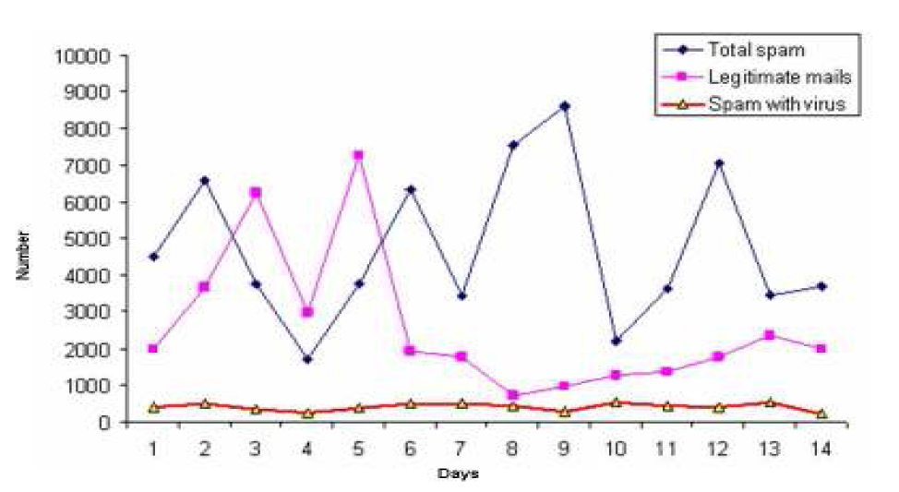
Figure 1. Spam traffic sample
All figures, tables, etc. must have a caption, centre-justified in 11 pt. Times New Roman. Captions precede tables but follow figures. Tables and figures must appear as close to their point of reference as satisfactory formatting of the final document permits.
2.9. Acknowledgement
An (unnumbered) acknowledgements section may be inserted if required.
2.10. References
References should be cited in the main text, in passing [1] or explicitly as in [2]. The full references should be given as below (essentially IEEE format), in the order in which they are cited, in 10 pt. Times New Roman, with a 6pt spacing between each.

3. Conclusion
Papers in this format must not exceed six (6) pages in length. Papers should be submitted to the secretary of University Journal FAUJIRP. Papers for initial consideration may be submitted both in xxx.doc and xxx.pdf format. Final, camera-ready versions should take into account referees’ suggested amendments.
Acknowledgement
The authors would like to thank everyone, just everyone!
References
[1] Lee, S.hyun. & Kim Mi Na, (2008) “This is my paper”, ABC Transactions on ECE, Vol. 10, No. 5, pp120-122.
[2] Gizem, Aksahya & Ayese, Ozcan (2009) Communications & Networks, Network Books, ABC Publishers.

Instruction for all authors
- The submitted paper must be not more than 6 pages. If you submit paper with many pages, the additional charges must be paid.
- The formatted paper according to AUJIRP format will only be accepted. If you submit paper without AUJIRP format, the submitted paper will not be published.
- The submitted paper in Myanmar Language can be up to 7 pages with pyidaungsu font 13 size.
- If you have question, please let us know through Journal Secretary.
- If your paper will be accepted to publish, we will let you know bank account number to transfer journal fee.
- All submitted papers will be checked for plagiarism.

